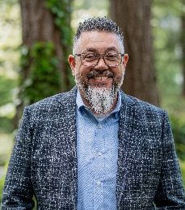


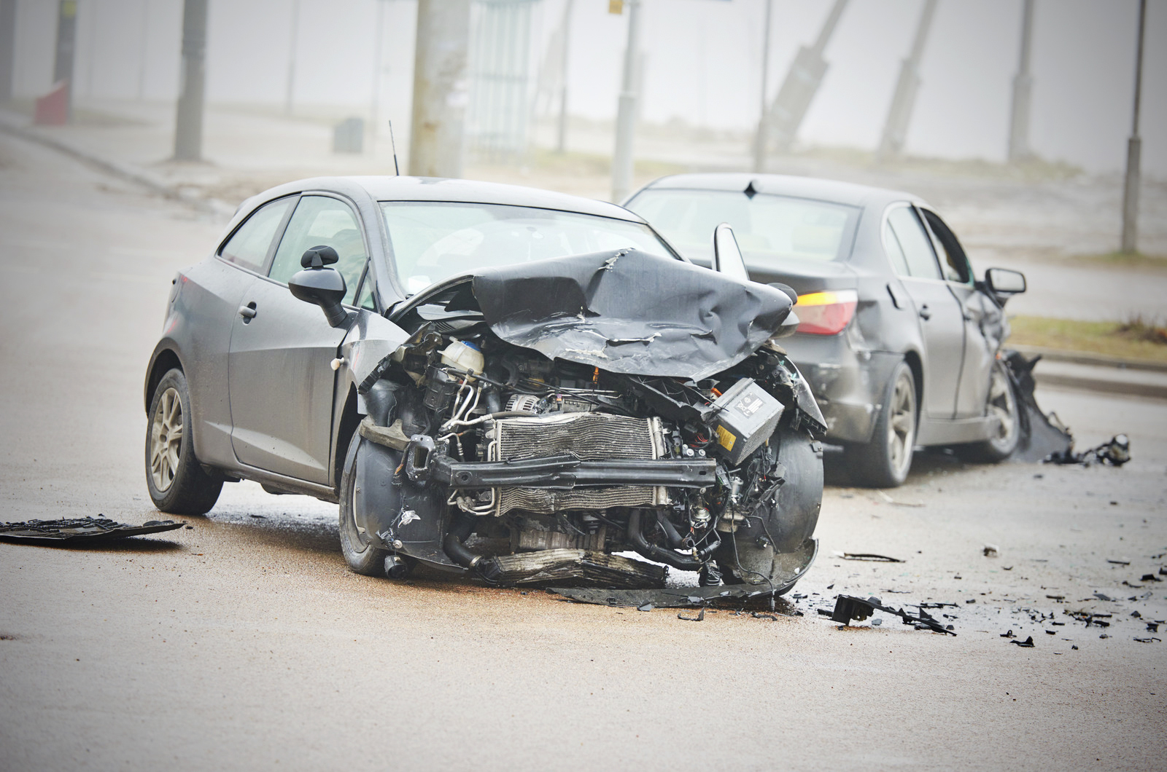

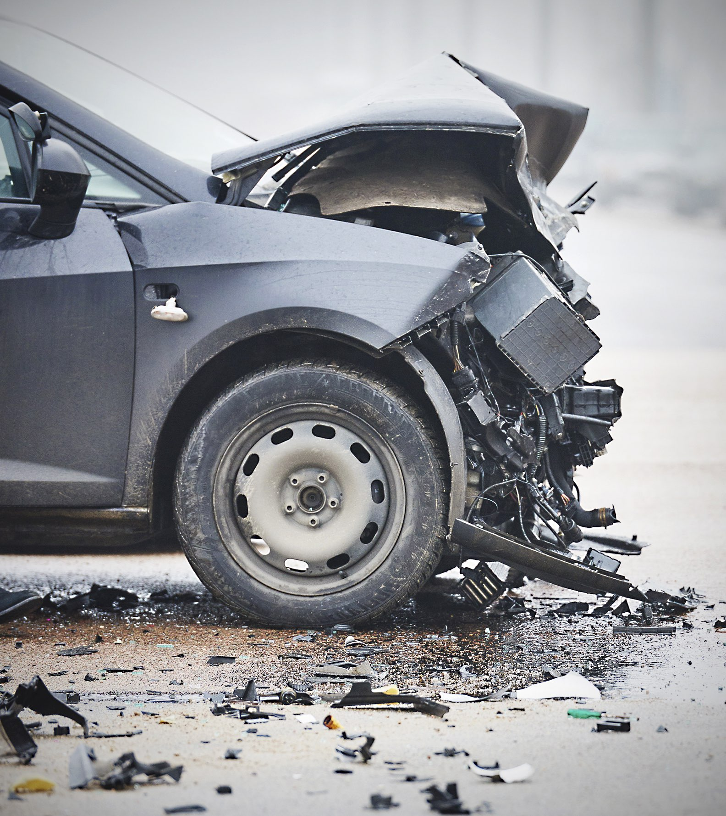
Not at fault? You Still
Need an Attorney
Here’s why…

Hiring an attorney costs you nothing
and puts a powerful advocate on your side.

Advertisers want you to believe that insurance companies care. But they are not interested in what’s best for you.

Making sure you are
treated fairly is our job!

Put the law on your side; Ranz Injury Law. We’ll fight to preserve your rights, and to ensure that you are fully compensated for all damages caused by your accident.
Call Us Before Talking to
Your Insurance Company.

RANZ INJURY LAW
(206) 429-5227
REAL TALK,
REAL SOLUTIONS

Car Collision.
What Now?

500 S 336th St, Suite 100
Federal Way, WA 98003
(206) 429-5227
david@ranzlaw.com

Top 5 Reasons To
Hire Ranz Injury Law:
- Passionate, personal service, providing diligent and creative representation.
- Flexible and convenient appointment times, located near you.
- You only get one chance to tell your story. Choose the firm that will ensure you are heard.
- If you’ve been hurt, don’t let insurance companies hurt you again.
- We don’t get paid until you get paid! Call today for your free consultation.
Your actions following a crash
can determine your long-term financial and physical health. Know what to do and what
to say after a collision.

Talk to Ranz Injury Law first.
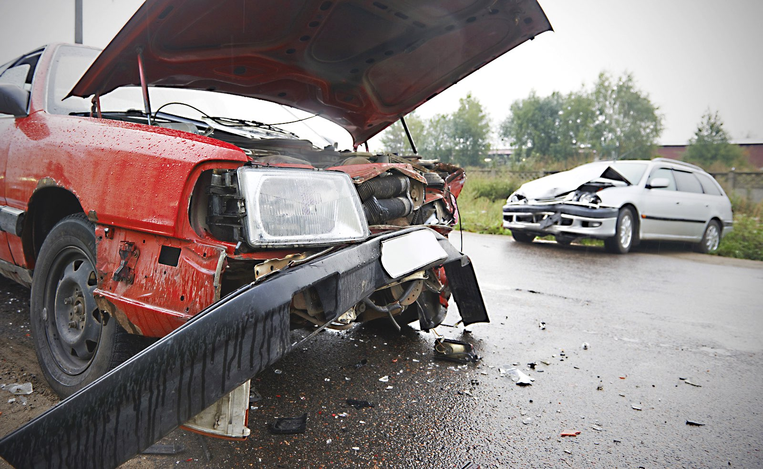

Give to driver of other vehicle:

Your Name ______________________________________________
Your Address __________________________________________
___________________________________________________________
Your Phone _____________________________________________
Drivers License # ______________________________________
Date of Birth ____________________________________________
Make/Model/Year of Vehicle _________________________
___________________________________________________________
License Plate # _________________________________________
Owner of Vehicle _______________________________________
Owner’s Phone ________________________________________
Owner’s Address _______________________________________
___________________________________________________________
Passenger(s) ____________________________________________
____________________________________________________________
Your Ins. Agent __________________________________________
Agent’s address _________________________________________
Agent’s phone __________________________________________
If you have a cell phone, we recommend that you take pictures of the scene, all vehicles involved, and the driver’s licenses of other drivers.
Fill out and keep for your records:

Date ______________________ Time ___________________________
Location _____________________________________________________
Names(s) of Other Driver(s) _______________________________
________________________________________________________________
Address(es) of Other Driver(s) _______________________ ________________________________________________________________________________________________________________________________
Phone # of Other Driver(s) ____________________________
________________________________________________________________
Policy # of Other Driver(s) ____________________________
________________________________________________________________
Name(s) of Witness(es) _______________________________
________________________________________________________________
Address(es) of Witness(es) ____________________________
________________________________________________________________
Skid Marks ▢ Yes ▢ No
Measurements _____________________________________ Feet
☑︎

☑︎

☑︎

☑︎

☑︎

☑︎

☑︎
✔
Stop and move your vehicle to a nearby safe location.

Call for assistance if anybody is injured. Assist the injured if possible.
Call the police. They can record details and establish the cause of the collision.
Gather information yourself using the adjoining checklist.
Be careful what you say. Don’t speculate about the cause of the collision and don’t make statements to the police.
Call Ranz Injury Law. Get legal advice first to protect your rights and ensure you are treated right.
(206) 429-5227
Notify your insurance company. But do not make a statement about cause or medical condition of anyone involved in the crash.
Collision Checklist:
✔

RANZ INJURY LAW • Email: david@ranzlaw.com • Phone: (206) 429-5227
In Case of a Crash…

